**Final Project Proposal**: Hadarou Sare #50245420

**Title:** Using R to predict behaviors, demands and dynamics through times and distances in two cases: Predict behavior of police agent and suspect in a zone; Predict Blood Group_A Demand (BGAD) and Group_A (GA) dynamics in a village.

**Introduction**

One of the of advantage of coding is to be able to extract the exact information, predict behaviors, predict demands based on people’s needs, find the dynamic of a system based on diverse factors as quickly as possible in order to propose a range of solutions to leaders who might decide what to do in any given situation.

In this project, we will study the behavior of police agents through time in an area whose mission is to capture a suspect. Note that every suspect has also a behavior which change through time and we will examine that too. In addition to that, we will examine the availability of a blood Group A through time in a village and the demand of that blood group A in the same village through time as well.

**Data**

I will create my own data but those data will be incorporated in the code I will develop

**Method**

I will use the differential equation functions in R to get any result I will be looking for in this project. For the first case, the ODE function will be use in R. In the code, a model equation will be shown. The flux due to diffusion, the rate of change, the model parameters, the condition will be implemented. For the second case, the model equation, the model parameters, and the conditions will be implemented.

**Results**

In both case, the results will be shown in pictures. The results will show the behavior of polices agents and the behavior of the suspect through time in case one. In case two, the result will show the demand of the blood Group A as well as its availability in the village through time a distance. I show here how the results will look like.

**Case1 images:**

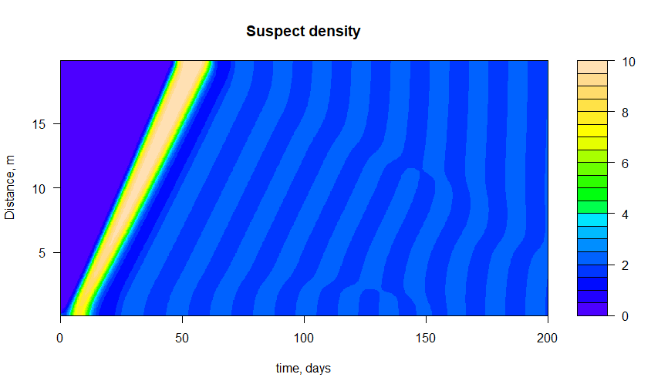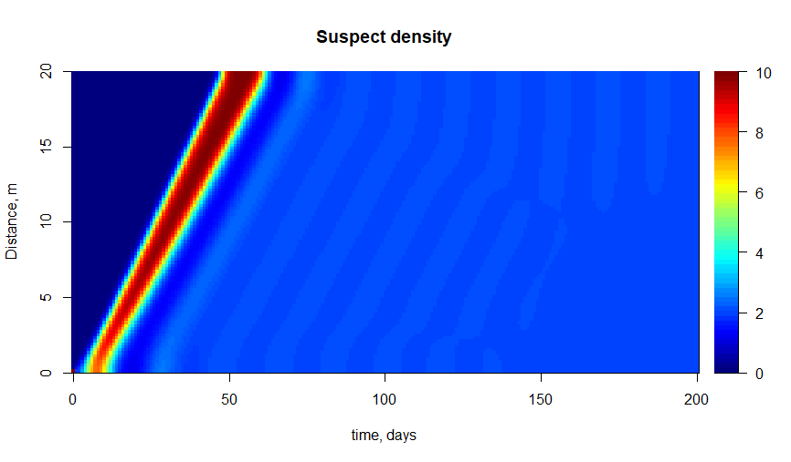

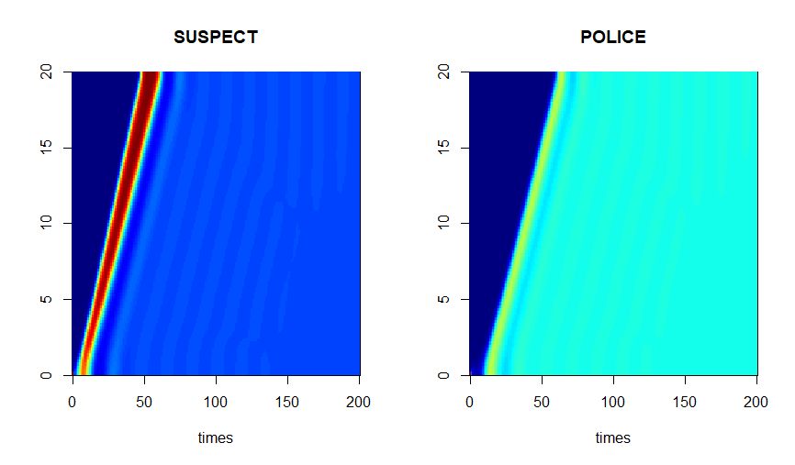

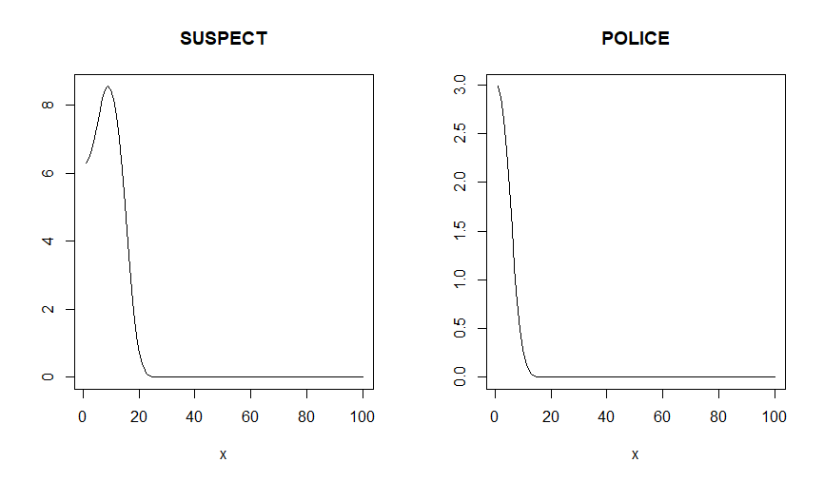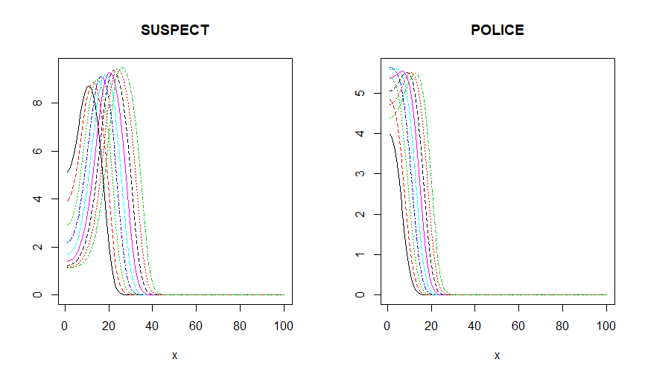

**Case2 images:**

